Online Supplementary File

Contents
Figure S1: Fluoroquinolone (FQ) consumption and prevalence of antimicrobial resistance to fluoroquinolones in Neisseria gonorrhoeae (Ng) and Escherichia coli (Ec) in 30 European countries 2
Figure S2: Macrolide consumption and prevalence of antimicrobial resistance to azithromycin in Neisseria gonorrhoeae (Ng) and macrolides in Streptococcuc pneumoniae (Sp) in 30 European countries 3

Figure S1: Fluoroquinolone (FQ) consumption and prevalence of antimicrobial resistance to fluoroquinolones in Neisseria gonorrhoeae (Ng) and Escherichia coli (Ec) in 30 European countries

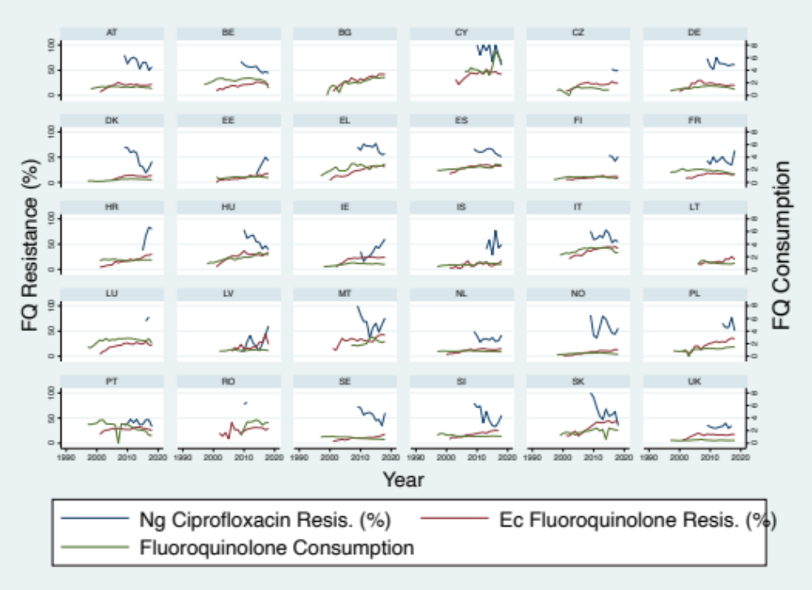

Abbreviations: AT, Austria; BE, Belgium; CZ, Czech Republic; DE, Germany; DK, Denmark; EE, Estonia; EL, Greece; ES, Spain; FI, Finland; FR, France; HR, Croatia; HU, Hungary; IE, Ireland; IT, Italy; LU, Luxembourg; LV, Latvia; NL, the Netherlands; NO, Norway; PL, Poland; PT, Portugal; SE, Sweden; SI, Slovenia; SK, Slovakia; UK, United Kingdom.

Figure S2: Macrolide consumption and prevalence of antimicrobial resistance to azithromycin in Neisseria gonorrhoeae (Ng) and macrolides in Streptococcuc pneumoniae (Sp) in 30 European countries

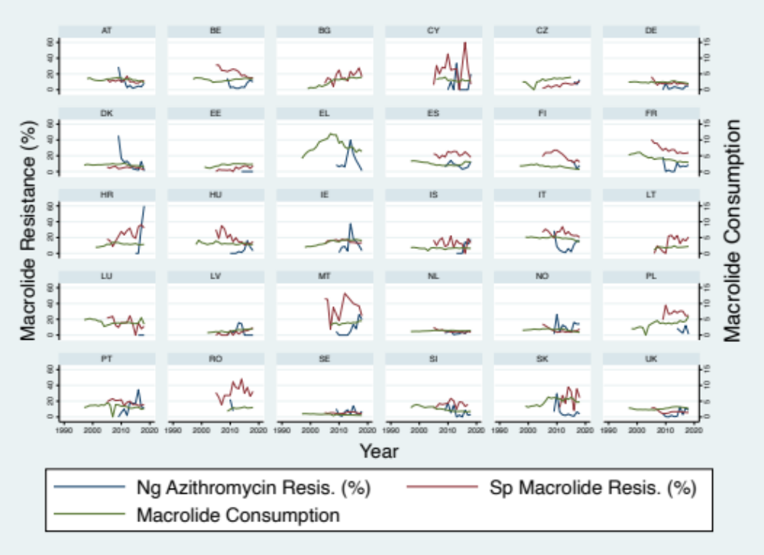

Abbreviations: AT, Austria; BE, Belgium; CZ, Czech Republic; DE, Germany; DK, Denmark; EE, Estonia; EL, Greece; ES, Spain; FI, Finland; FR, France; HR, Croatia; HU, Hungary; IE, Ireland; IT, Italy; LU, Luxembourg; LV, Latvia; NL, the Netherlands; NO, Norway; PL, Poland; PT, Portugal; SE, Sweden; SI, Slovenia; SK, Slovakia; UK, United Kingdom.

